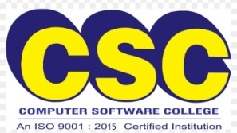

**FREE SEMINAR ON**

DATA SCIENCE & AI

TALLY PRIME WITH GST & ADV.EXCEL

Gather on the most anticipated free seminar in this season and gain knowledge.



**Come along with your Friends. Participate Certificate will be provided**.

**REGISTER NOW!**

**WHATSAPP US: 8668058567**

**THEME:**

**DATA SCIENCE**

**&**

**ARTIFICIAL INTELLIGENCE**

**Saturday,**

**12 October 2024**

**Timings: 10:00AM – 12:00 PM**

**THEME:**

**ADV. EXCEL**

**Sunday,**

**13 October 2024**

**Timings: 10:00AM – 12:00 PM**

**VENUE:**

**CSC ADAMBAKKAM**

**#63, 1st Floor, Above Balaji Electricals,**

**Adambakkam, Chennai – 88**

**Ph: 6385122714 / 7904803226 / 8668058567**

**Follow us on instagram: cscadambakkam**